Abstract— The growing availability of ratings and textual user reviews has grown into an important information resource. This rich information resource of ratings and textual reviews has clearly shown brand new methods to solve many important problems that have been confounding the research community for years, for example, the cold-start paradox, the explanation of recommendation, and the automatic generation of user profiles or item profiles. Thus, the fundamental importance of ratings and textual reviews has obtained a wide recognition. This may be mainly because of the complexity in formatting, structuring and analyzing the texts. The success of a business can be improved if it is located near its complementors. For example, spas can attract more customers if they are located near beauty salons.
Business Trends and Potential Business Opportunities – Yelp Dataset Analysis
Sunil Kumar
Therefore, this paper has two goals. The first is to identify the complementors for each category using the Yelp’s dataset with data mining techniques. These complementors are filtered using cluster techniques to extract only the most important business categories. The second goal is to use this dataset to locate the best opportunities by using various techniques to open a business so that the business is close to its complementors with least competitors. The work presented in this paper is limited to the state of Pennsylvania (USA), in particular Pittsburgh. However, the methodology is extensible to other cities from the Yelp’s dataset.

INTRODUCTION
In this approach, we try to learn the popularity of businesses based on user’s ratings and reviews by evaluating the past choices of other users. Hybrid recommender systems can be used to merge the benefits of various strategies to make more advanced recommendations. Review text and ratings can be evaluated and used in a variety of ways and our main aim is mining all business reviews and ratings to evaluate the popularity of a business or product. The assumption is that businesses with many positive ratings would have high reviews and determining the business with most positive reviews in a particular time period allows us to rank businesses on popularity. With this goal, we aim to determine the current business trends in a particular location and try to predict the business or product that could be successful based on the user interests and market demands. growth rate. Based on these trends and interests, potential business opportunities could be predicted and tested.
Yelp has provided a way for users to review and rate local businesses which is similar to the way users rate products in online stores. The total rating for a business is the average of all the ratings for that business given by the users. Usually users make their decisions based solely on the business’ average star ratings when exploring new businesses. The average star ratings do provide a pretty good idea about how good the business is and what people think about the business, but this method ignores many other bits of information, including the business attributes, the users, the ambience, the location and the review text. A lot of work has been done to consume this information in much better ways.
Yelp has been organizing dataset challenges for a few years where students use Yelp data to come up with fun, innovate and creative ways to generate great new insights and opportunities find hidden factors and topics in the text to justify the rating accompanying the review. Latent subtopics from review texts using online LDA, and predicted star ratings for each of the latent topics can be used to discover current trends and interests.
There are various factors that can influence a business’ success. Competing businesses, popular locations, social and cultural influences and marketing techniques are some of the factors that can influence the success or collapse of a business. As the number of these parameters increases, it gets harder to answer to this question. However, studying and analyzing the customers’ behavior can help us to get a better insight on this question. For example, if people from a particular travel a long distance to go to a beauty spa, then we can understand that starting a beauty spa closer to those people has a great potential of success.
By a new business, we refer to the category of that business and our system will suggest terms like 'beauty and spa' hair salon. New business suggestions are made in two different categories. The first category is the nonexistent businesses in a particular location for which people need to go to a different location. This predicted category might not cover all of the potentially successful businesses. Also the prediction is made only for those businesses categories that have received high business ratings and stars and which in turn suggests that they are popular categories. Thus if there is a business that is popular in adjacent location clusters, then we use these categories to find the complementary businesses. The second category of businesses consists of categories that are existent in a location but are sparse and also have very low popularity among users and. Thus this category suggests business that could potentially become popular since the existing businesses are less common in a location and also have very low popularity.

The steps we follow are as follows - first, the businesses are clustered based on location within a one-mile radius. Then, we compute the top business interests in a particular area using all the review ratings and the review counts. Then, we run a regression algorithm to predict the business that will continue to get popular and the business that will lose popularity in the next six-month span. Then the extract these predicted businesses and weigh them to find the complementors in each cluster by running an association rule algorithm. We also find new business from existing categories that has a high scope to be successful.

DESCRIPTION

Data Acquisition
Yelp is an online database of local businesses and provides a great means for users to discover, review and rate the businesses and services they visit. Over the years, Yelp has collected a huge database of users, businesses, and reviews. Yelp has made a subset of the data available to the scientific and academic community by organizing challenges, and has opened up a lot of opportunities for analyzing and using this data for different purposes in different ways. Businesses create their own listings, and highlight the products and services that will appeal to users and attract them to visit and rate the business. Yelp covers a vast variety of businesses, like restaurants, bars, cafes, events and services, beauty and spa, doctors, pharmacies, hotels etc. Users have their own accounts and can maintain friends. Yelp maintains its own social network with information on friend lists, likes votes etc.
Yelp allows users give a star rating from 1 to 5 where 1 is the lowest and 5 is the highest for each business. The users are also allowed to write a text review justifying the rating number. These ratings serve as a great metric for other users who are looking for local business, which help them to decide the best business for them. This has made Yelp a great recommendation system. Each business has a total rating that is an average of the star ratings that the business has received for all the reviews. Users are also allowed to vote each review written by different users and the votes can be marked as funny, cool, or useful.
The dataset consists of five different files. Each file consists of one JSON object per line.
The object types are - business, review, user, check-in, tip. A description of all the fields in each of the object types is a follows:
- Business
Each business has a business id, location information such as latitudes and longitudes, full address, the number of reviews written for the business, and an average star rating across all the reviews. Yelp also stores other information like hours, categories, ambience, and so on.
- Review
Each review consists of a star rating and a review text. The review datatype also connects the users to the businesses they review. Each review can also get votes from other users, who can say if they find the review cool, funny, or useful
- User
Yelp has a rich user network, where it stores information about them like name, the number of reviews they have written, how long they have been using Yelp and also creates its own social network by having friend relations between the users. Users can even be fans of each other.
- Checkin
This is an object that provide a view of all the check-ins for a business at each hour of the day, for each day of the week. This gives information about what are busiest times for each business.
- Tip
Tips stores random comments that users give about a business. They are different from reviews and they don’t have a star rating and are just quick indications for others.

Feature Extraction and Selection
All the files from yelp dataset are processed by loading them into spark. The data is processed and we select extract the dataset for the state of Pennsylvania. A lot of pre-processing is done on the files to extract the required data in the required format. After the initial processing the move to the feature extraction stage.
From the Yelp business file, we select the following features as columns into one file: business_id', 'review count', 'stars', 'categories', 'city', 'state', 'full address', 'latitude', 'longitude', 'name', 'users_sum', 'ratings_avg'.
From the Yelp review file, we select the following features as columns into one file: 'business_id', 'state', 'review_count', 'user_id', 'review_id', 'text', 'stars', 'review_count', 'fans', 'votes[useful]', 'yelping_since', 'date'. These columns are then written into an excel file and further features are extracted and added. The date in the reviews file range from 2005- 2015 and thus the years are weighted such that 2015 has the highest weight. Similarly, we extract the reviews and review count year wise and they are weighted from an exponential function. This process is continued to calculate the weights for all the following features. year_weighted', 'review_count_weighted', 'fans_weighted', 'votes_weighted', 'weighted_users', 'weighted_rating', 'users_sum', 'ratings_sum', 'ratings_avg', 'after_Jun2015', 'after_Jan2015', 'after_Jun2014', 'after_Jan2014', 'after_Jan2010'.

Methodoloy
Once we have the initial preprocessed data and features, a series of data mining and prediction algorithms are run on the data to get the results. First the business id, latitudes and longitudes are extracted from the business file and the businesses are clustered using Hierarchical clustering algorithm. Thus the clusters that contains the highest number of locations are computed. The algorithm proceeds by grouping the data one after another based on the nearest distances measured from all the pairwise distance between the data items. The distance between the data items are recalculated and there are many available methods to consider the distance when the groups are formed. Some of them are: single nearest distance, centroid distance, complete farthest distance and ward's method.
Hence the grouping is continued on the data items until a cluster is formed and then based on the dendogram graph, the number of clusters that should be actually present are calculated. Hence in our approach we use the centroid distance method to form the clusters and all the business that are within one-mile distance from the centroid are grouped into one cluster. The advantage of using Hierarchical clustering is that we need not pre specify the cluster numbers.
The next step is to run a regression algorithm on the business file with the selected features and inputs to the regression model. the regression model selected is Random Forest Regression. Random Forests are highly accurate and ensemble learning method for regression and classification that build numerous decision trees during the training time and output the class which is a mode of the classes given out by individual trees. Random Forests are a blend of tree predictors in which each tree relies on the values of a random vector sampled independently with similar distribution for all trees in the forest. The principle is that a "strong learner" is formed by grouping of "weak learners". The main advantages of random forests are as follows.
1. Gives an estimation of which variables are important in the classification
2. Accuracy
3. it can handle large number of input variables without the problem of variable deletion
4. Runs efficiently even on very large data sets
5. Provides powerful methods for approximating missing data
Thus the regression model is outputs the predicted ratings for each business in a cluster that would be popular and unpopular in the next 6 months. These output is then used to extract calculate the weights of each business using the predicted ratings. A business whose predicted rating is more than the current ratings is considered as a popular business with a positive weight and a business whose predicted rating is more than the current ratings is considered as not popular business with a negative weight.
The next step is to extract all the popular businesses in each cluster and calculate the weights of each business categories from the weight values obtained from the prediction algorithm. Once we know the weights of each business we then rank the business from highest weighted business to lowest weighted business in each cluster. Then we build Association rules on these business categories to get the rules for complementor businesses. Association rule analysis is a method for finding interesting relations between parameters in data sets. An association rule is an expression X->Y, where X and Y are disjoint data items. The strength of an association rule is measured by its support and confidence. Support evaluates how frequent a rule is applicable to a data set and confidence evaluates how frequently items in Y show up in transactions containing X. Support is a critical measure since a rule that has low support may just appear by chance. Thus a low support rule is possibly not interesting from a business perspective. Confidence evaluates the reliability of the reasoning made by a rule. Thus for a given rule X->Y, higher confidence means it is more likely for Y to appear in a set that has X.
The next step is take the rules and check in each cluster if all the complementors are present in a cluster or not. if any of the complementors are not present in a cluster then we say that the complementor business could be a potentially successful business is established in that cluster.

Evaluation
Spark is used for preprocessing the data and filtering the columns that are required for the project. Apache Spark is a cluster computing framework that provides an application programming interface which is centered on a data structure called resilient distributed dataset (RDD). RDD is a read-only multiset of data points distributed over a cluster of computing machines, which is managed in a fault tolerant way.

IPython Notebook is used as the python environment to run the code for processing the Yelp dataset files and extracting the features. IPython is an interactive Python shell that provides parallel and distributed computing. Apache Spark provides an SQLContext which is used to convert the JSON into pandas object for further processing of the data.

Hierarchical Clustering Models
The next step is to extract the business id, latitudes and longitudes from the business file and the businesses are clustered using Hierarchical clustering algorithm. The Hierarchical clustering algorithm was run on R-programming language. Hierarchical clustering was chosen since we could limit the cluster radius to one-mile radius and we need not provide the number of clusters. The workflow is these steps is as shown.

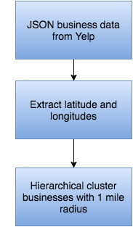

Figure 1: Hierarchical clustering of businesses using location information

The algorithm returned an output where each file business id was assigned to a cluster and the total number of clusters were 558. The plot businesses on the cluster is as shown. An interesting trend in each cluster was that businesses that were usually rated low where less common. The business with high ratings in each cluster occurred densely in each cluster. From this we can infer that a new business from this category of businesses could potentially become popular since the existing businesses are less common in a location and also have very low popularity. Further studies are done on this during the next stages.

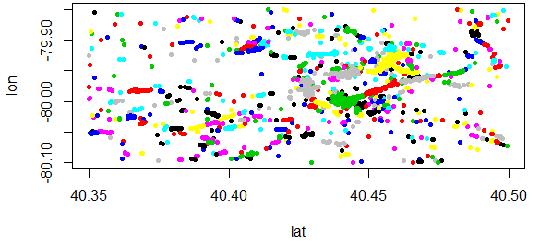
Figure 2: Plot of business clusters in Pennsylvania

Random Forest Regression Model
Now the next step is extract the features for the regression algorithm. The features selected for the regression analysis are as follows.
'clusters_id' - The cluster to which each business is allocated
'regression_value' - Regression value is the product of review count for each business and its average star ratings
'after_Jan2010_count' - This is the count of all review for a business from Jan 2010 till Jan 2014
'after_Jan2014_count' - - This is the count of all review for a business from Jan 2014 to June 2014
'after_Jun2014_count’ - This is the count of all review for a business from July 2014 to Dec 2014
'after_Jan2015_count’ - This is the count of all review for a business from Jan 2015 to June 2015
'weighted_regression_value' - This is a normalized regression value calculated from a weight function
'ratings_avg' - This is the average star rating for each business
'users_sum' -

The workflow is the steps for the regression model is as shown.

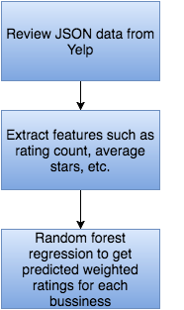

Figure 3: Random Forest Regression for businesses to predict the weighted ratings.

Association Rules Analysis
The output of the regression model is used to extract the input for the association rules algorithm. This is done as follows: The predicted weighted-rating for each business is marked as positive if the business has an average business star ratings of 3.5-5, and the predicted weighted-rating is marked as negative if the business has an average business star ratings less than 3.5. The next step is to check for each cluster what is the total predicted weighted-rating of each business in the entire cluster. For example, if in a cluster there are 3 coffee shops with predicted weighted-rating as 20, 50, and -30, then the total weighted-rating for coffee shop in that entire cluster is calculated as 40. This process is repeated for all the categories in all the clusters.
In our approach we only consider the top 10 most highly rated businesses since these business indicate the group of most popular complementor businesses for each cluster. Thus the top 10 most popular business categories from each cluster are given as input to the association rules algorithm. This algorithm is run is r language and the output is noted. and the output is a rule matrix consisting of the complementor business. The rule matrix includes 4 columns, 'rule_value', 'rule_key', 'support' and 'confidence'. The support and confidence column values describe the strength of an association rule. The rule_value columns can consist of many businesses but the rule_key column consists of only one business. A subset of the rule matrix is as shown.

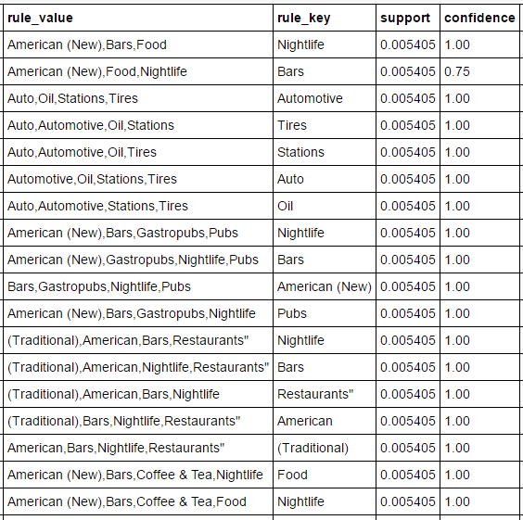

Figure 4: Association rule matrix output from the association rule algorithm.

From the association rule matrix, it can be easily observed that complementors are businesses that are closely associated. For example, American(New), Food, Bars and Nightlife are complementor businesses. In another example it can be seen that Automotive, Oil, Stations, Tires and Auto are all complementor businesses. This shows the predicted complimentors are in line with human intuition. The next step is to check in each cluster if the complementor business are present or not and if there is an opportunity to start a potential business. This is done as follow: Each cluster is checked to see if its top 10 businesses list consists of at least one of the businesses from the rule_key column. If a cluster includes a business from the rule_key column, then we check if it has the businesses from the associated rule_value column. Thus if the cluster consists of all the businesses from rule_value column then we say that cluster is already saturated and there is no new business opportunity. However, if a cluster has the business from rule_key column but does not have a business from its associated rule_value column then we say that there is an opportunity to establish this business in that cluster. This procedure is performed on all the clusters to check for all the potential business opportunities. The final output consists of a pandas object with two columns 'Category_key' and 'Complementary_business'. Each Complementary_business column is a python dictionary object that where the keys consist of cluster numbers and the values consists of the potential business opportunities in that cluster. A sample of the predicted business opportunities is as shown.

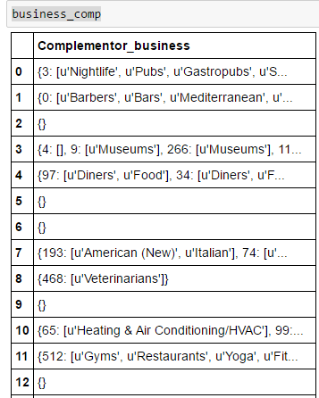

Figure 5: Predicted business opportunities in each cluster.

Related Work
In [1], there has been some relevant work done. They introduced a technique to categorize the relations between the businesses categories and from these relations find the best business opportunities by using the Yelp dataset. The main idea of this paper was to make use of the business categories to categorize patterns in the location of the businesses. This paper defines a method to examine the important features for the success of all small businesses in a particular area. They make use of Yahoo web-engine to extract the business categories, which are then clustered to generate the business opportunities. The method used here takes into account only the competitors and complementors without using any knowledge about the business environment or the customer’s needs. This work mainly revolves around the idea of clustering small businesses and predicting locations for a small business. Our approach uses the idea of predicting businesses for all location clusters and hence determine both ideal location and ideal business for each location. The businesses that were clustered on the basis on locations were also rated on their performance and popularity which was then used as a metric for business performance and complementor business detection.

Summary and Conclusions
This paper has introduced a new method to identify the relationships between the businesses ratings, review count and business categories. The main idea is to predict businesses for all location that were clustered with in a one-mile radius, for particular state or city and hence determine both ideal location and ideal business for each location by using the Yelp dataset. The key-idea is to utilize the ratings and review count to mark businesses on their popularity and then group each business into popular and not popular. There was a strong relationship between business that were popular. For example, if in a location restaurants and bars were popular then there was a high chance that nightlife or pubs were also popular in that location. These insights were gained from the model for one state, that is the state of Pennsylvania. But this approach can be clearly extended to all other cities or states. This model provides personalized recommendation for openings new businesses in a location. The entrepreneurs can use this model to determine the business and the locations new businesses. The method used in this paper can be improved in the future as follows.
- . Extend the business locations to all the states and use other dataset to identify the correlation and the location and businesses.
- . Consider the all categories in a cluster instead of just the top 10 businesses.
- . Use sentiment analysis on the reviews to analyze the user sentiments for the businesses based on the review text.
- . Use check-in information to accurately determine the time and day at which a business is busy and attracts more customers.

References
- Susplugas, Michael, Radhika Garg, and Burkhard Stiller. "Recommending Ideal Location for New Business based on Yelp Dataset.".
- Yelp: Yelp Dataset Challenge - Round five; http://www.yelp.com/dataset challenge/; last accessed in June 2015.
- Jennifer King Bryan Hood, Victor Hwang. Inferring future business attention. Yelp Academic Challenge Dataset, 2012.
- Scikit Learn. http://scikit-learn.org/stable/index.html.
- Zhang, Yongfeng. "Incorporating Phrase-level Sentiment Analysis on Textual Reviews for Personalized Recommendation." Proceedings of the Eighth ACM International Conference on Web Search and Data Mining. ACM, 2015.
- Hood, Bryan, Victor Hwang, and Jennifer King. "Inferring future business attention." Yelp Challenge, Carnegie Mellon University (2013).
- Jindal, Tanvi. "Finding local experts from Yelp dataset." (2015).
- Tzeng, Gwo-Hshiung, et al. "Multicriteria selection for a restaurant location in Taipei." International journal of hospitality management 21.2 (2002): 171-187.
- S. Chakrabarti: Mining the Web: Discovering knowledge from hypertext data; Elsevier, 2002.
- D. L. Olson, Y. Shi: Introduction to Business Data Mining; Vol. 10, Englewood Cliffs McGraw-Hill/Irwin, 2007.
- P. J. Clark, , F. C. Evans: Distance to Nearest Neighbor as a Measure of Spatial Relationships in Populations; Ecology, pp 445-453, 1954.
- H. Degryse, S. Ongena. Distance, Lending Relationships, and Competition; The Journal of Finance, Vol. 60, No. 1, pp 231-266, 2005.
- M. Porter: Cluster and the New Economics of Competition; Harvard Business Review, Vol. 76 (1998), pp. 77-90.
- G. Van Rossum, F. L. Drake J: Python Tutorial; Centrum voor Wiskunde en Informatica, 1995.
D. Crockford: The Application/JSON Media Type for Javascript Object Notation (JSON); Network Working Group, Request for Comments: 4627, 2006.

  Author is with the Computer and Information Science and Engineering Department, University of Florida, USA (e-mail: sunilzs@ufl.edu).

